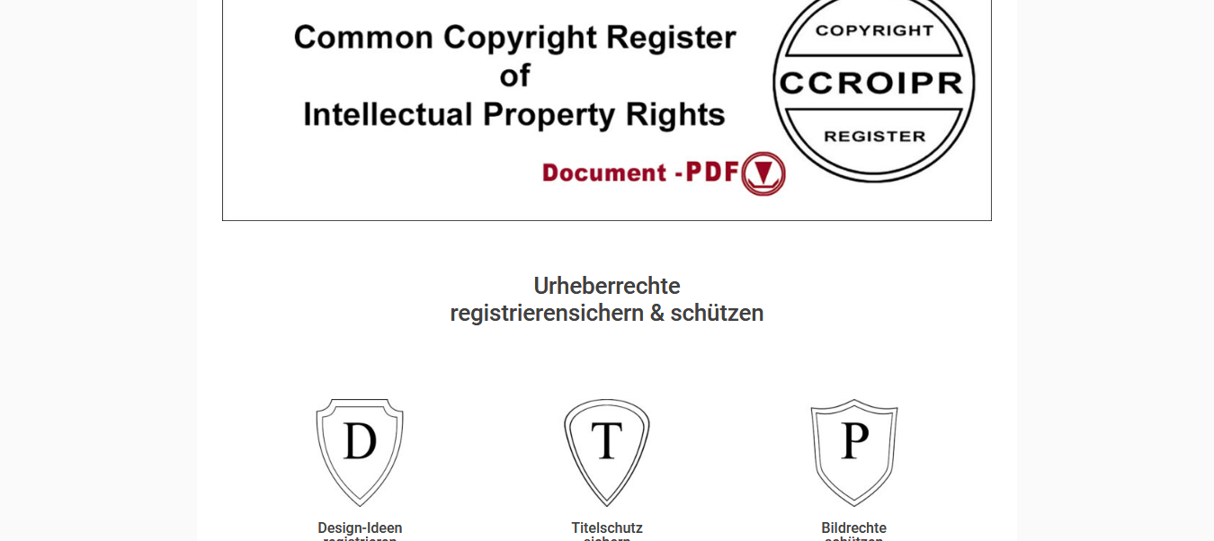

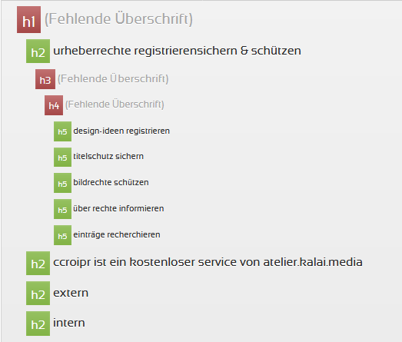

H1 is missing
H2 is wrong
____________________
Please just copy and paste the Text or whole expression!

<H1> Copyrights

<H2> Urheberrechte <br> registrieren - sichern &amp; schützen

